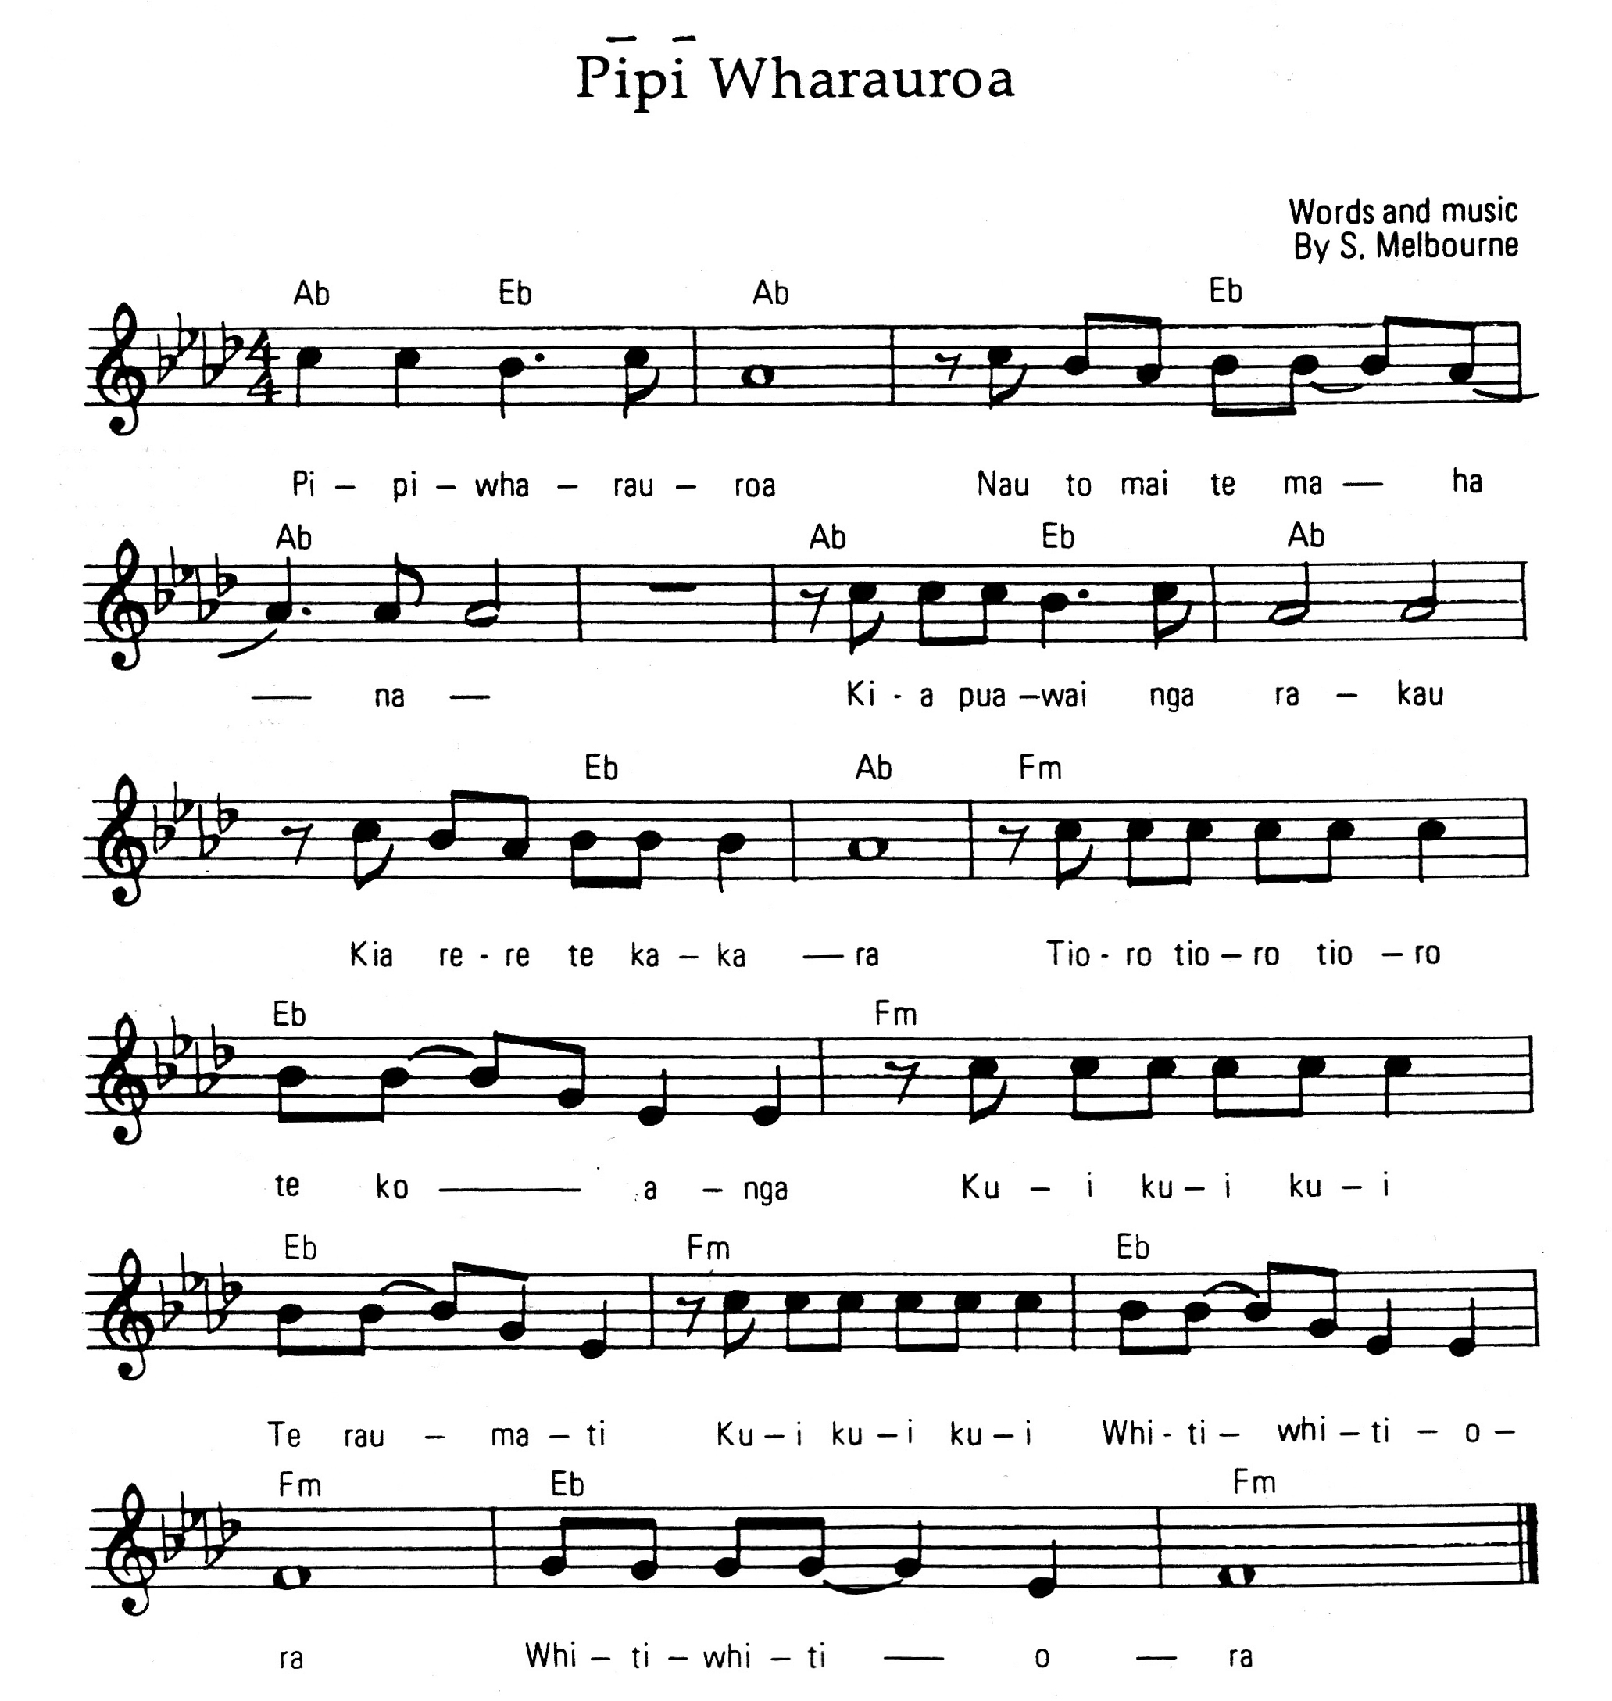

Source: Waiata Maori: Wahanga tuatahi, Vol 1, compiled by H T Rikihana, 1997

