THE SHINING CUCKOO

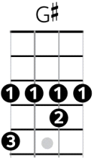
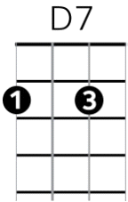
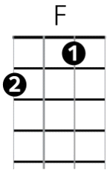
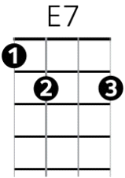
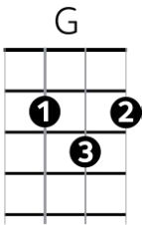
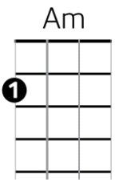
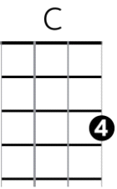
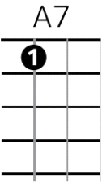
Fogarty / Warne 2012

Chorus

C Am G E7 Am

The Shining Cuckoo sings the start of Spring, you cross the ocean on those tiny wings,

F G C Am F G C

Pipiwharauroa, Shining Cuckoo, don’t you know that we love you?

Verse 1

E7 A7

In the forest you’ll be found, scoffing caterpillars down, keeping Kowhai green and strong,

D7

But you’ve got a naughty streak, to the Warbler’s nest you sneak,

G G# G

Laying your eggs in places they don't belong.

Chorus - The Shining Cuckoo….

Verse 2

E7 A7

All those islands in the sun, Norfolk, Lord Howe, Solomon, Cuckoo's staying nice and warm,

D7 G G# G

Back in Aotearoa, where temperatures are lower, other birds are facing all the wintery storms.

Chorus - Shining Cuckoo….

Verse 3

E7 A7

Yet in spite of what you’ve done, you are still the chosen one, showing us the journey home,

D7

Flying far beyond our reach, passing Ninety Mile Beach,

G G# G

Across the wide Pacific Ocean you'll roam

Chorus - FINAL CHORUS

[ Ending – Coo-koo-ke-doo !]

